Mohamed Elsayed Emam Abouelfotoh
Task 3 Network
configure switch router and switch and
enable telnet , svi , default gateway

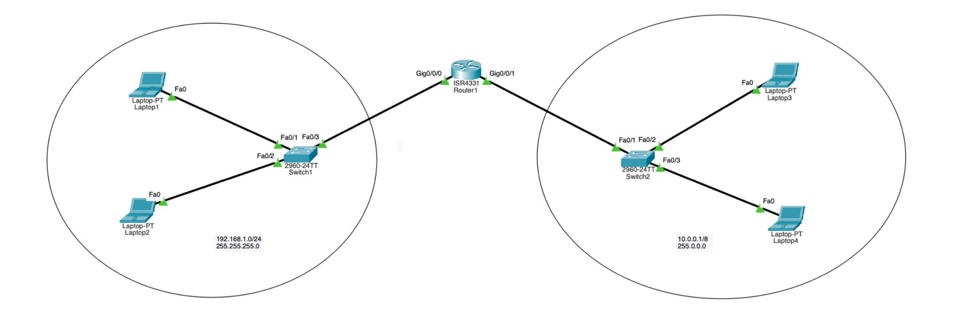

Router 1
1-hostname core-1
2-console password: 333
3-banner login: "welcome everyone"
4-encryption to all passwords
5-enable secret (privilege mode)

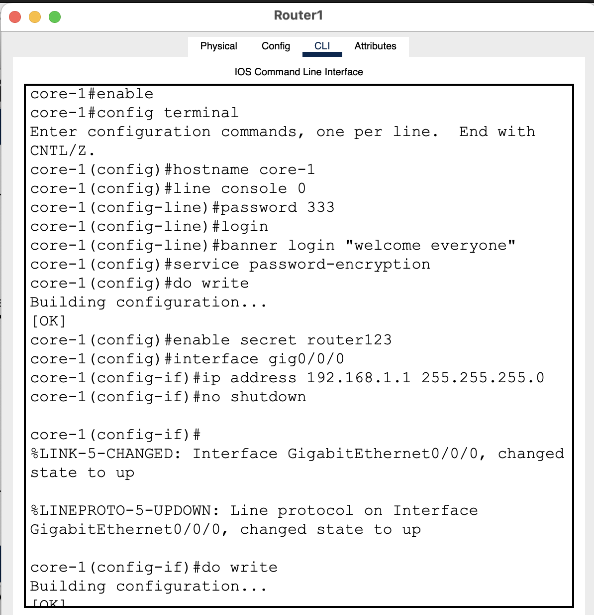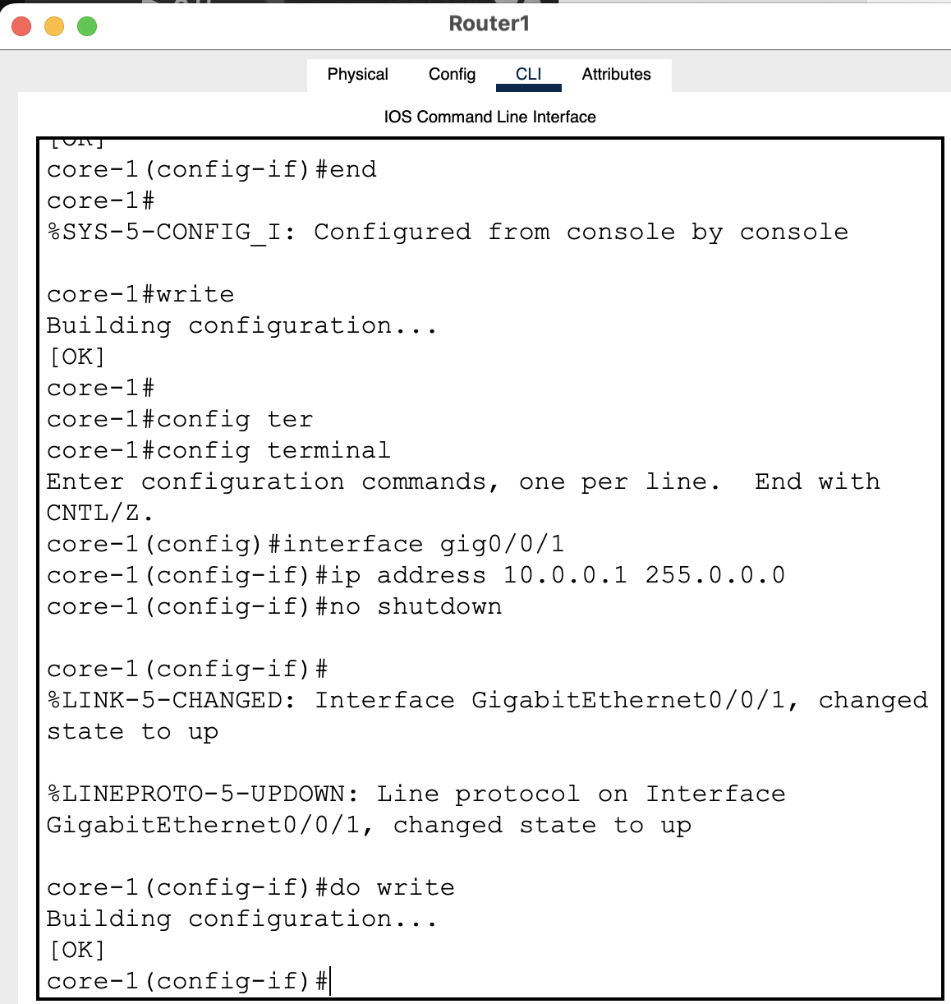

Switch 1
1-hostname floor-1
2-console password: 123
3-banner motd: "welcome everyone"
4-encryption (service password-encryption)
5-enable secret (privilege mode password)
6-telnet: username & password
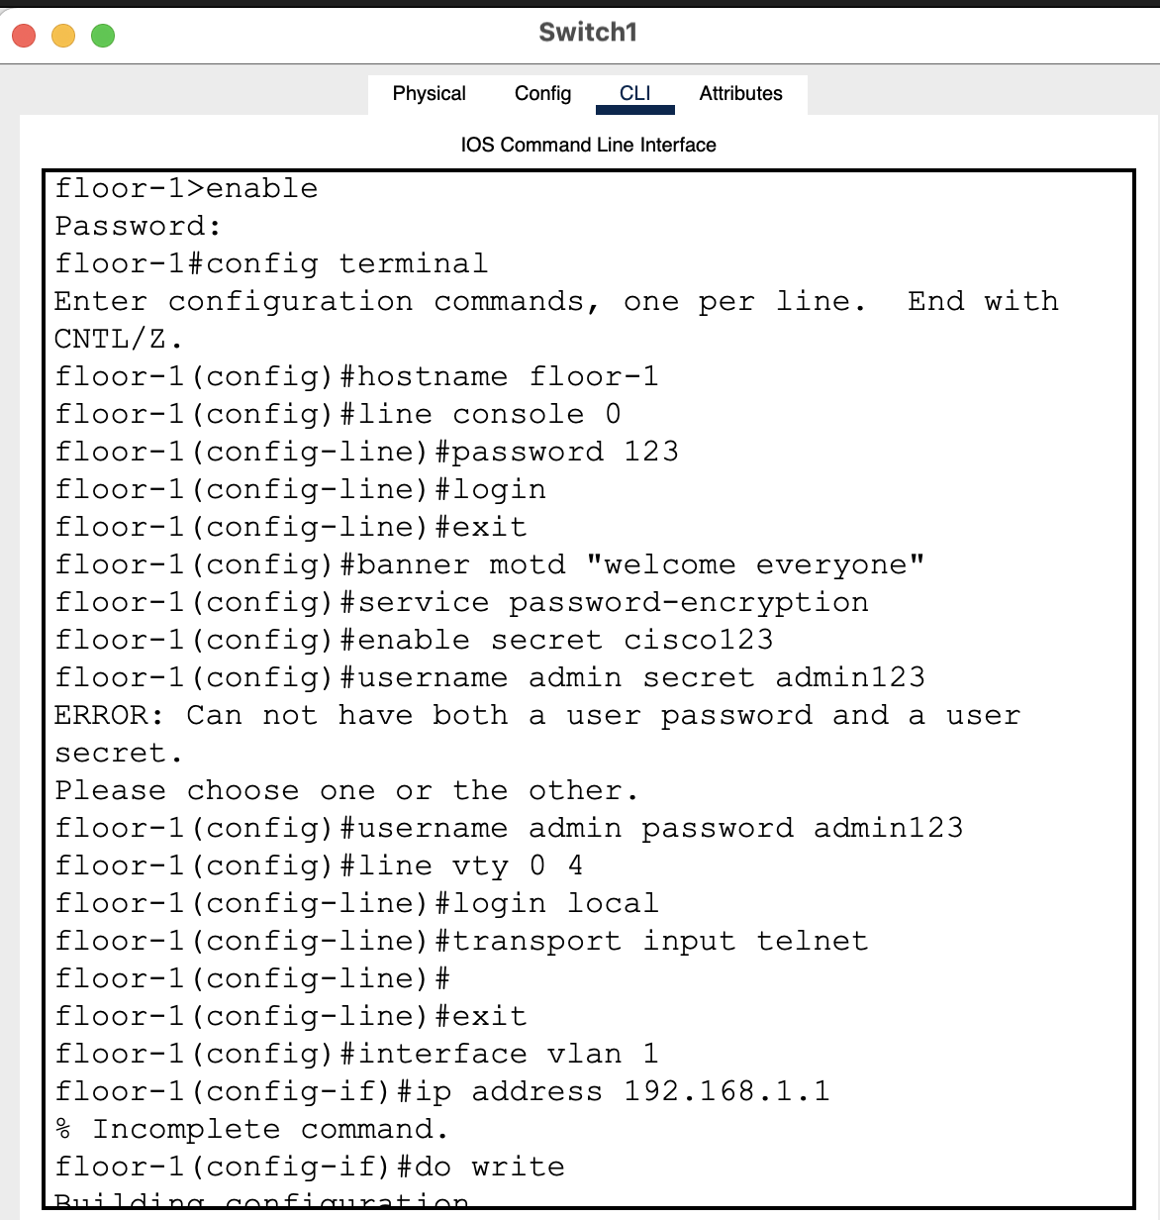
Switch 2
1-hostname floor-2
2-console password: 222
3-banner motd: "welcome everyone"
4-encryption (service password-encryption)
5-enable secret (privilege mode password)
6-telnet: username & password
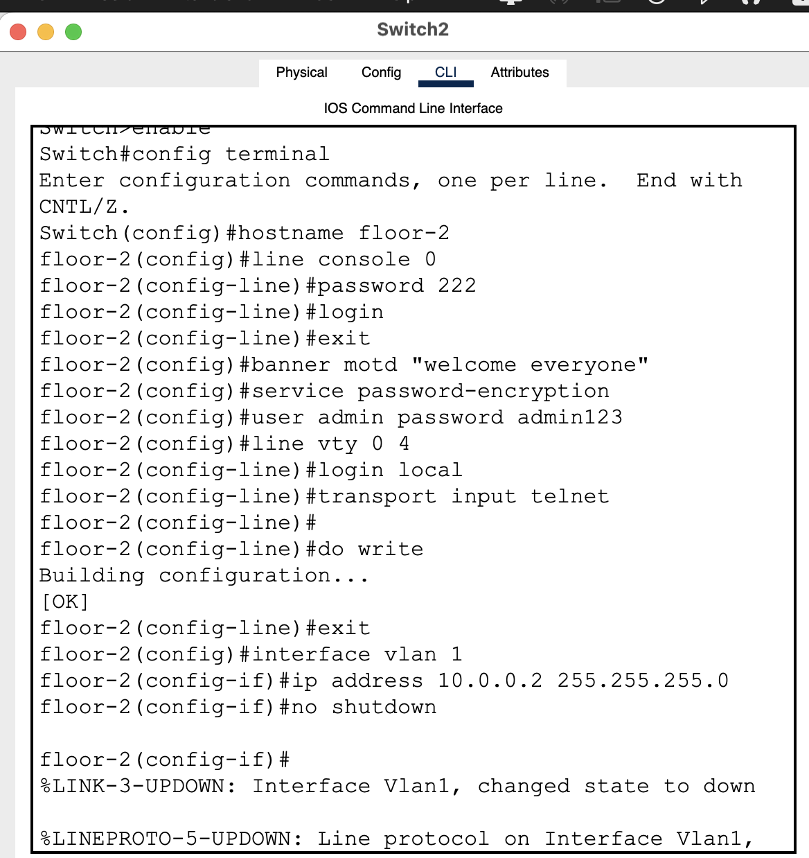
Ips for all laptops
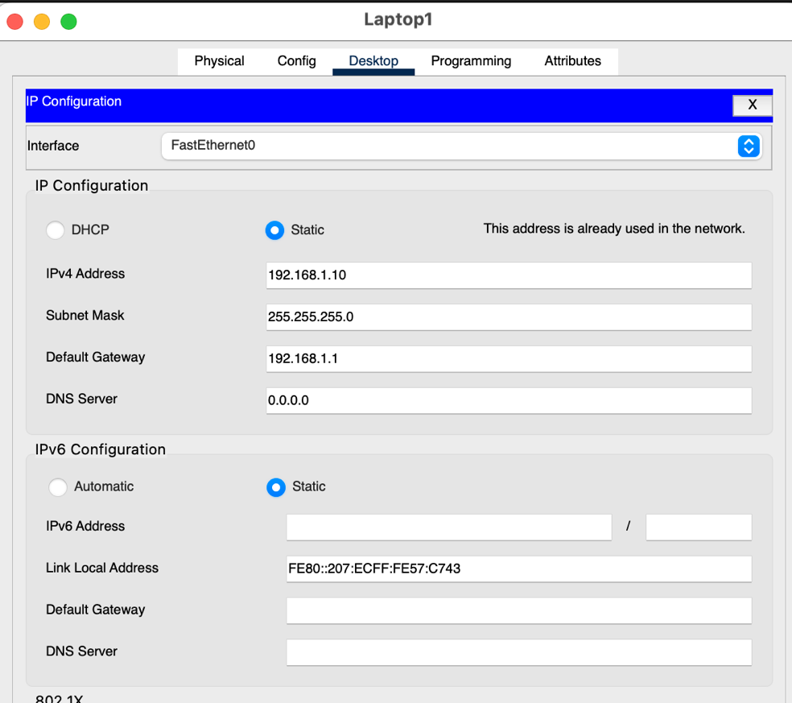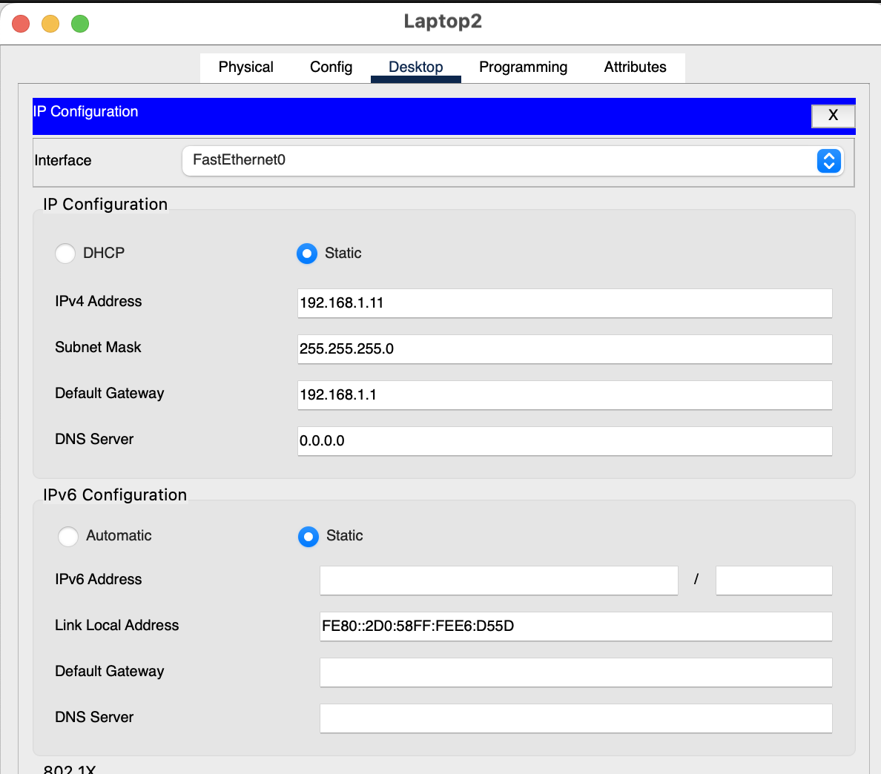
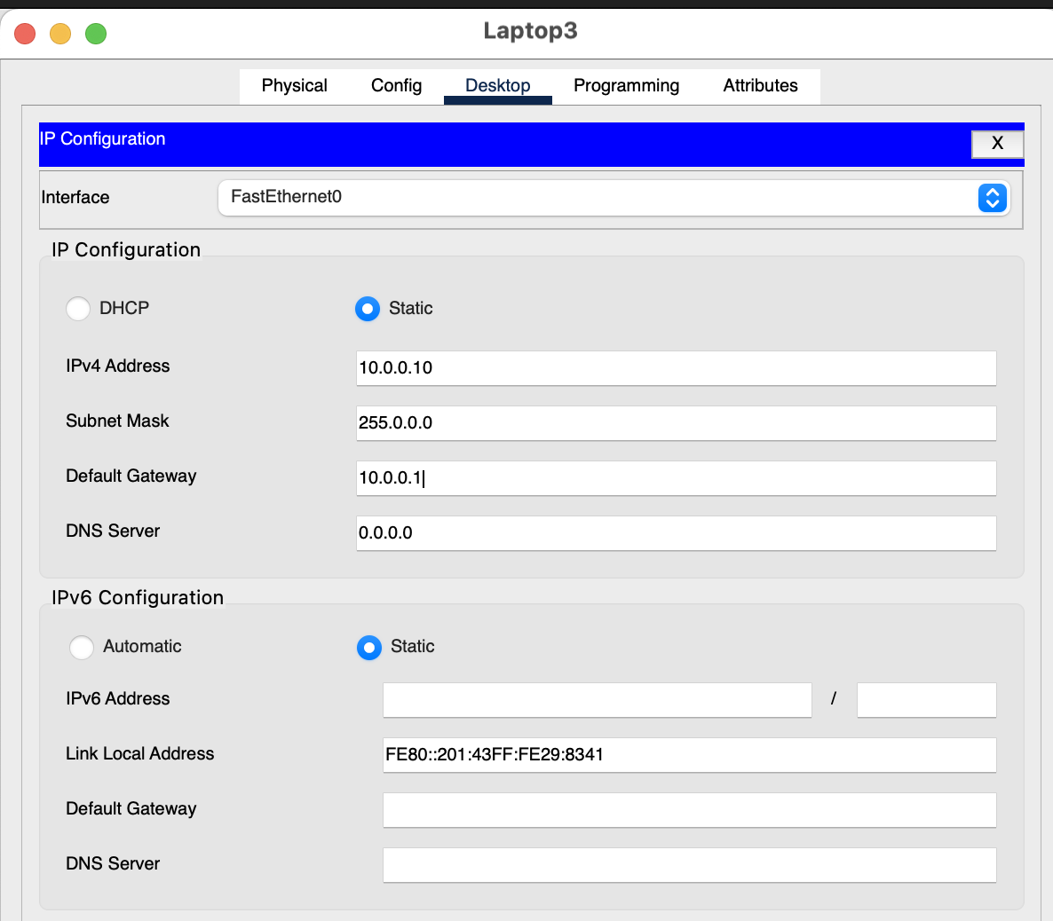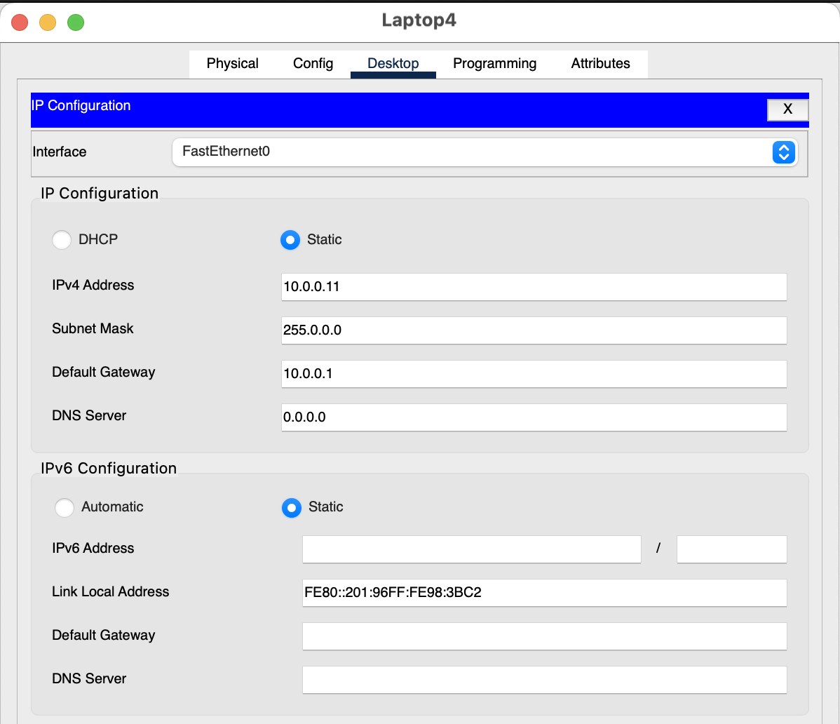
Test everything with ping and telnet protocol
